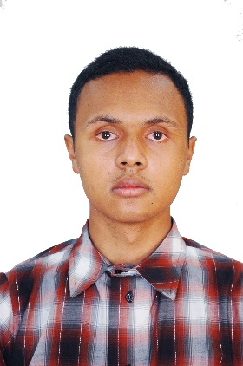

**RANDRIANJAFY Mahery Antonio**

**PROFIL**

**DIPLOMAS Y HOBBIES**

**Formaciones :** Diplomados, Congresos, xxxxxxxxxx xxxxxx xxxxxxxxx xxxxxxxxxxxxxxxxx

**Hobbies:** xxxxxxxxxxxxxxxxxxxxxxxxxxxxxx



**Frontend Web Developer**

**EXPERIENCES PROFESSIONNELLES**

**Development of a web application "Ejeryemploi" for timetable management at the ASJA University**

Hi! I am Antonio, I'm a motivated junior frontend developer who loves learning and building great web experiences. I'm looking for a new position where I can grow my skills and work with talented teammates. I'm a good person to collaborate with!

July 2023 – in progress

* Frontend development using React.js, Backend with Express.js and PosgreSQL as the RDMS
* Maintenance sur différents projets.

**Interuniversity Hackathon 4th Edition | *Techzara - P4H***

March 25th-26th 2023

**CONTACTS**

* Integration of a mobile application developed in React Native with Airtel Money API



randrianjafymahery@gmail.com



**Hackathon organised by Hairun Technology | *GE-IT***

034 77 778 26

December 16th-17th 2023



* Development of a web application integrating APIs connected to smart sockets, utilizing HTML, CSS, and JS

ANTANANARIVO, Madagascar



**Exploratory Internship | Akany Risika Antsirabe**

www.linkedin.com/in/randrianjafy-mahery-701121210

July – August 2022

*

2017

*Private High School Saint Joseph Antsirabe*

**High School Degree**

*Excelsior School Language Antsirabe*

2018 – 2019

**English Course**

2019 – 2021

**Bachelor's Degree in Software Development**

*Athénée Saint Joseph Antsirabe University*

2022 – 2023

*Athénée Saint Joseph Antsirabe University*

**Master degree in Software Engineering**

**EDUCATIONS & FORMATIONS**

As an intern, I assisted with network and system maintenance, managing multiservices and internet connection for both the center and the Cyber Center.

**INTEREST and HOBBIES**

Guitar, Chess, Rubik’s cube

Malagasy

French

PostgresSQL

Git/Github

English

**LANGUAGES**

JavaScript

Next.js/React

React Native

Tailwind CSS

Node/Express.js

HTML/CSS

**SKILLS**

©AZURIUS – Modelos-de-curriculum.com